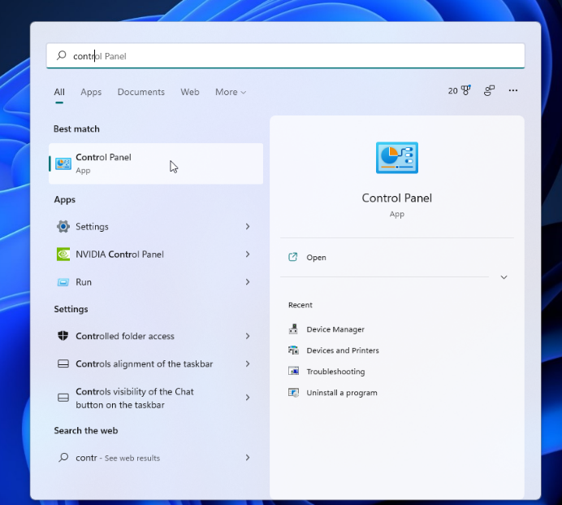**3.4 I can set up and use permissions to filter information**

To set up another user on a windows device one needs to visit the control panel. This can be reached by typing in *control* into search bar, accessible from the windows icon on the taskbar.

Alternatively, search for *add, edit or remove other users*

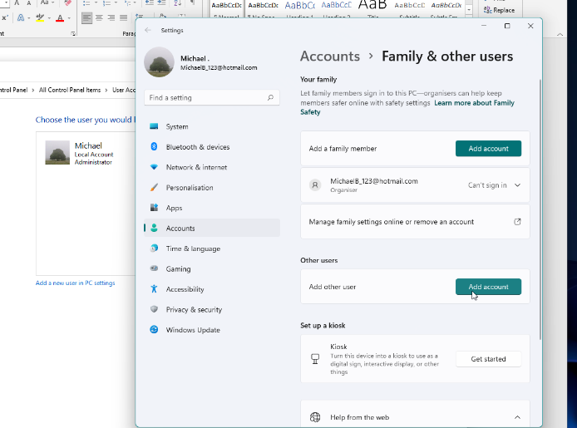  
From there:

* select *User Accounts*
* select Manage another account
* click *Add a new user in PC settings*

This launches a new window where you can add a new user

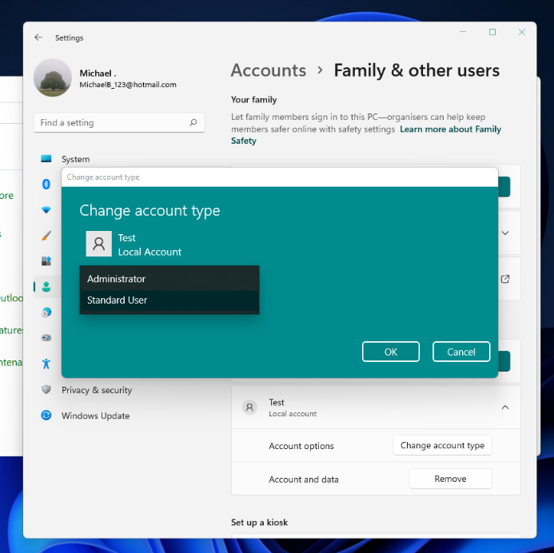

Once created, one can change the account type to Administrator or keep standard.